WRF Show Schedule 2020
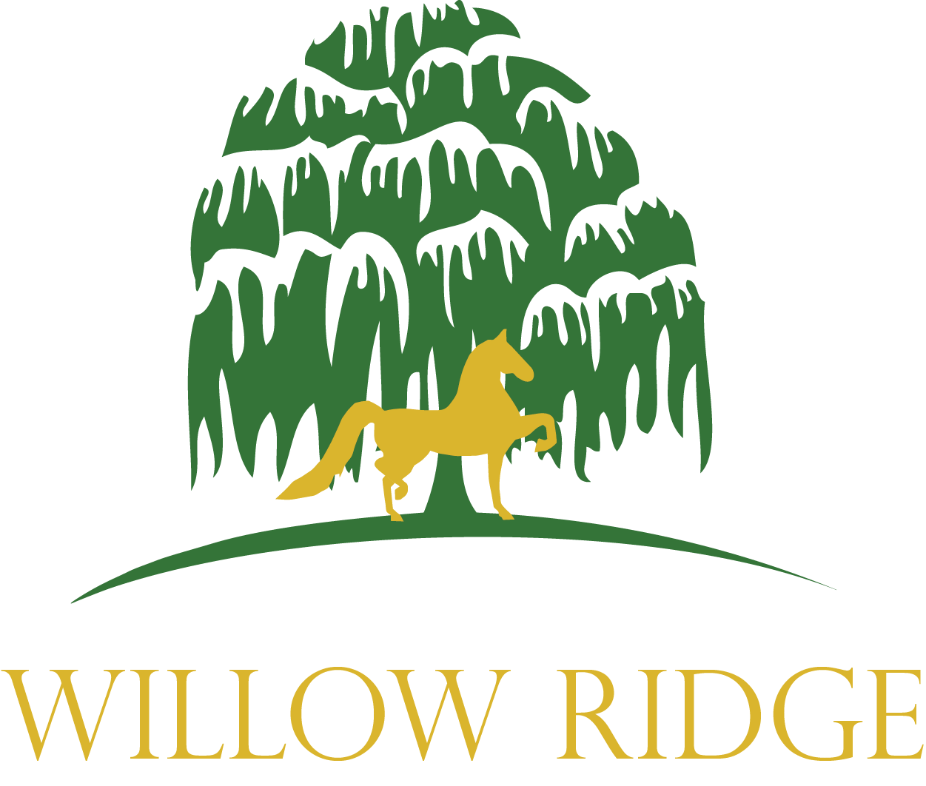

Indiana Spring Classic April 9-11
Shipshewana, IN

F.A.S.H. Spring May 7-10
St. Paul, MN

Prairie State Classic May 29 - 31
Woodstock, IL

Morgan Gold Cup June 10 – 13
Columbus, OH

Morgan Masterpiece July 16-18
Oshkosh, WI

Buckeye Morgan Challenge August 12-15
Springfield, OH

Jubilee Regional September 2-5
Springfield, IL

Morgan World and Grand National October 10-17
Oklahoma City, OK

** Schedule is subject to change. 6 or more entries are necessary for shows over 200 miles (Excluding OKC)****

